

**Green University of Bangladesh**

**Department of Computer Science and Engineering(CSE)**

**Faculty of Sciences and Engineering**

**Semester: (Summer, Year:2022), B.Sc. in CSE (Day)**

**LAB REPORT NO :07**

**Course Title: Structured Programming Lab**

**Course Code: CSE 104 Section: DE**

**Student Details**

|  |  |
| --- | --- |
| **Name** | **ID** |
| **Md. Israil Fakir** | **221902125** |

**Submission Date : 11-Sep-22**

**Course Teacher’s Name : Md. Parvez Hossain**

**[For Teachers use only: Don’t Write Anything inside this box]**

|  |
| --- |
| **Lab Report Status**  **Marks: ………………………………… Signature:.....................**  **Comments:.............................................. Date:..............................** |

**Problem 01:**

**Write a C Program to convert a decimal number to an equivalent binary number using function.**

**Code:**

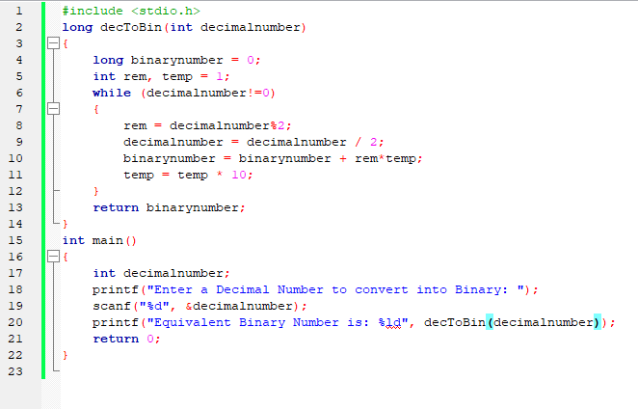

**Output:**

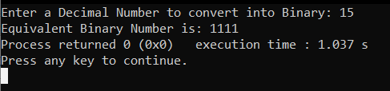

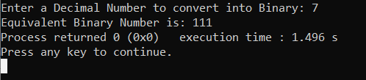

**Problem 02:**

**Write a C program to create menu driven calculator that performs basic arithmetic operations (add, subtract, multiply and divide) using functions.**

**Code:**

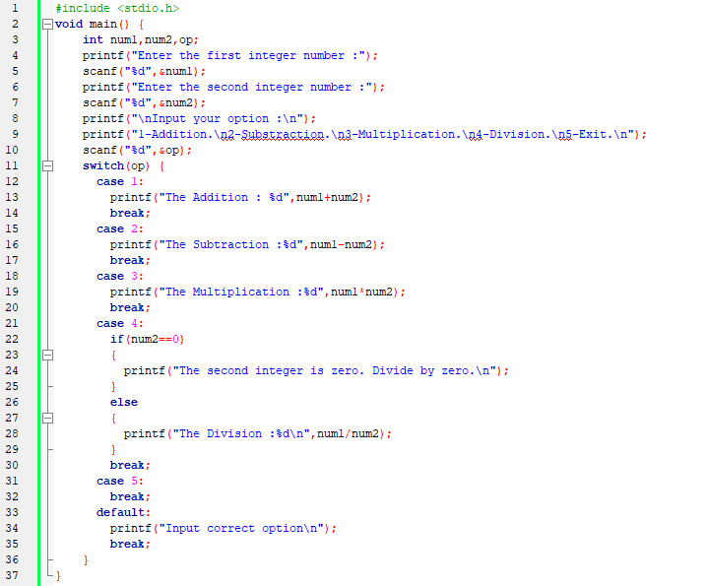

**Output:**

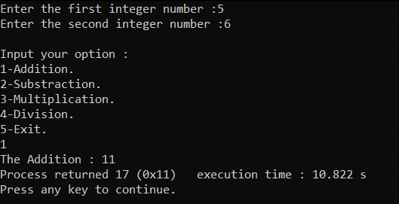

**Problem 03:**

**Write a C Program to print Strong Numbers between given interval using function.**

**Code:**

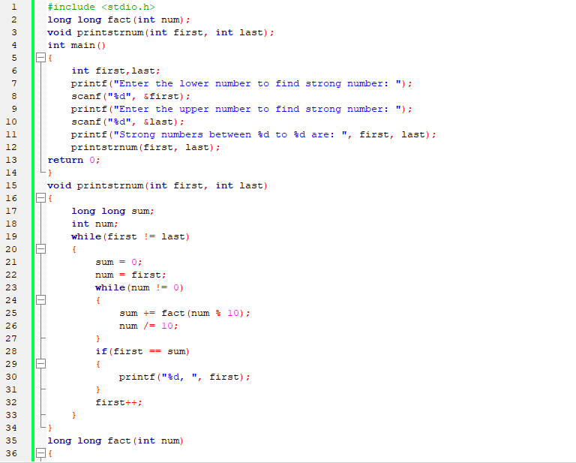 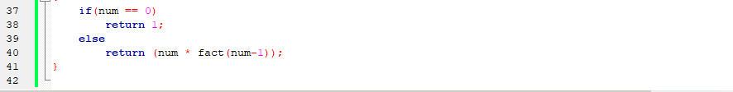

**Output:**

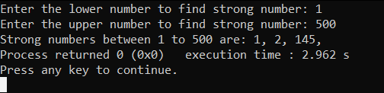

**Problem 04:** **Write a C program to calculate sum of all digits of a number using recursion.**

**Code:**

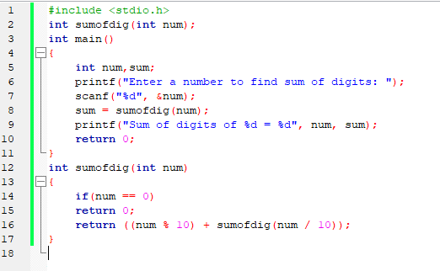

**Output:**

